## Read single character from keyboard and display next of the given character on the next line

.model small

.stack 100h

.data

.code

main proc

mov ah, 01

int 21h

mov bl,al

add bl,1

mov ah, 02

mov dl, 0ah

int 21h

mov dl, 0dh

int 21h

mov ah, 02

mov dl, bl

int 21h

mov ah, 4ch

int 21h

main endp

end main

## Read single character from keyboard and display previous of the given character on the next line

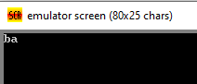.model small

.stack 100h

.data

.code

main proc

mov ah, 01

int 21h

mov bl,al

sub bl,1

mov ah, 02

mov dl, 0ah

int 21h

mov dl, 0dh

int 21h

mov ah, 02

mov dl, bl

int 21h

mov ah, 4ch

int 21h

main endp

end main

## Read capital character as input and display its small character and vice versa

.model small

.stack 100h

.data

.code

main proc

mov ah, 01

int 21h

mov bl, al

sub bl, 32

mov ah, 02

mov dl, 0ah

int 21h

mov dl, 0dh

int 21h

mov dl, bl

mov ah, 02

int 21h

mov ah, 4ch

int 21h

main endp

end main

## Write a code to peroform arthimetic addition and subtraction

.model small

.stack 100h

.data

.code

main proc

mov ah, 1

int 21h

mov bl, al

mov ah, 1

int 21h

add bl, al

mov cl ,bl

sub cl, 48

mov ah, 2

mov dl, 0ah

int 21h

mov dl, 0dh

int 21h

mov dl, cl

mov ah, 2

int 21h

mov ah, 4ch

int 21h

main endp

end main

.model small

.stack 100h

.data

.code

main proc

mov ah, 1

int 21h

mov bl, al

mov ah, 1

int 21h

sub bl, al

mov cl ,bl

add cl, 48

mov ah, 2

mov dl, 0ah

int 21h

mov dl, 0dh

int 21h

mov dl, cl

mov ah, 2

int 21h

mov ah, 4ch

int 21h

main endp

end main

## Printing A-Z

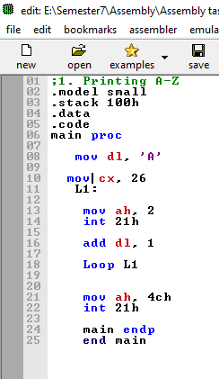

## Printing z-a

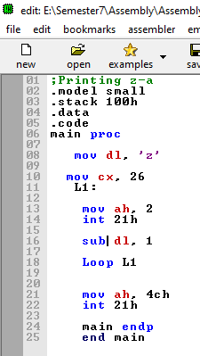

## To display Series of odd nos from 1 to 9

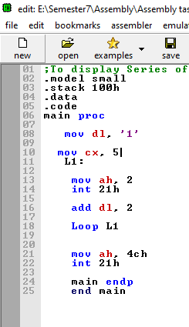

## To display Series of even nos from 0 to 8

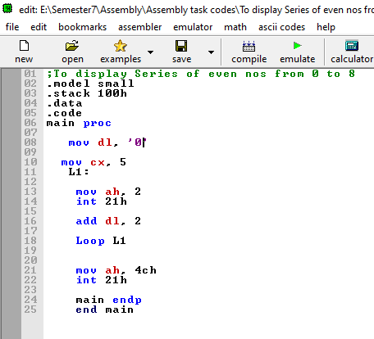

## To display Series of nos from 0 to 9

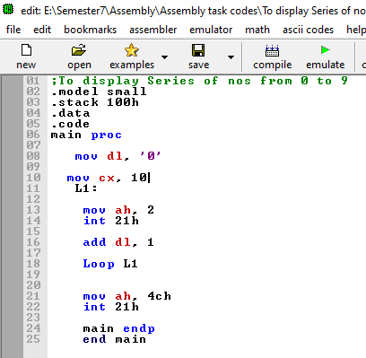

## To display Series of nos from 9 to 0

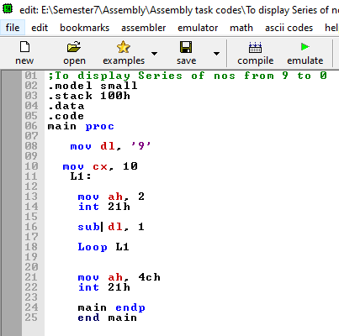

## Print nested loop patterns

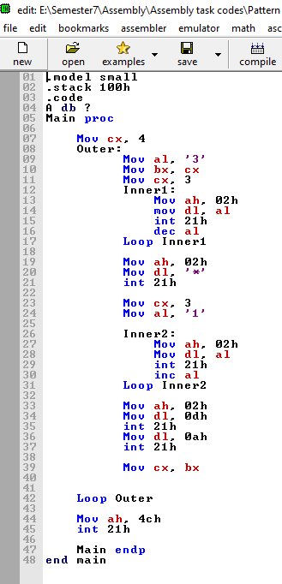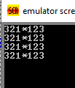

## Print nested loop patterns

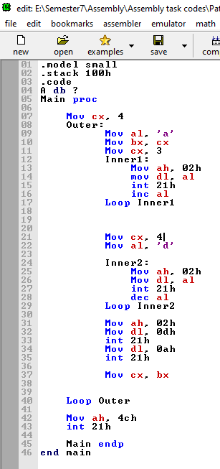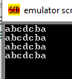

## Write to display from a to z skip one char on user choice

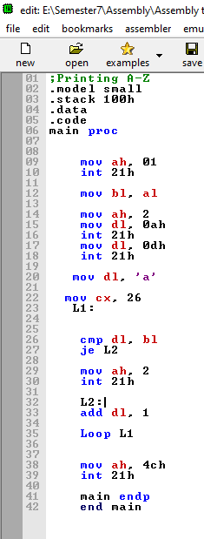 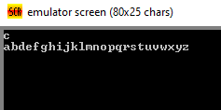

## Write a program to read two numbers and display maximum number

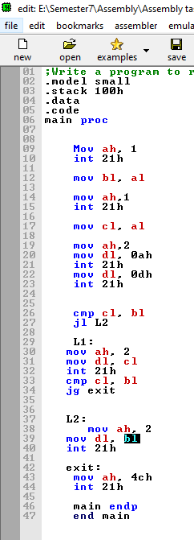 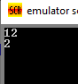

## Write a program to read two numbers and display minimum number

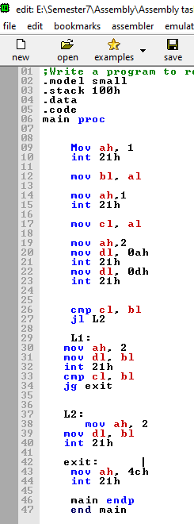 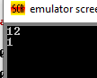

## Write a program to get alphabet from user and display the whole abcd instead of that alphabet



## Read a sequence of characters and count only capital alphabets

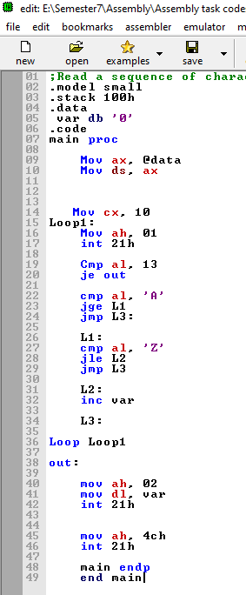 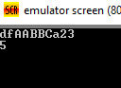

## Read a sequence of characters to count all alphabets

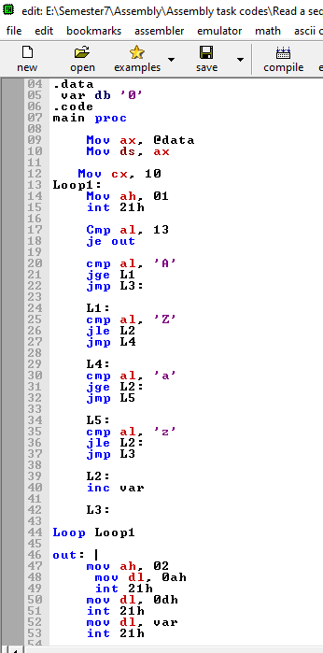 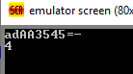

## Read a single number and display no in string. Print invalid if value is > 5.

